What is IR?
Information Retrieval (IR) is finding material (usually documents) of an unstructured nature (usually text) that satisfies an information need within large collections (usually stored on computers).

Effectiveness of an IR System
Precision : Fraction of retrieved documents that are relevant to users information need.
Recall : Fraction of relevant documents in collection that are retrieved.

To build IR system we need index the documents in advance.
Term-document incidence matrix
- Terms are the indexed units (usual words).
- Column: a vector for each document, showing the terms that occur in it.
- Row: a vector for each term, which shows the documents it appears in.
- Query: Answer Boolean expression of terms, do bitwise AND OR and NOT on vectors e.g.: 110100 and 110111 and 101111 = 100100.

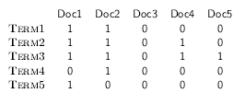
. . .
Entry is 1 if term occurs

Inverted Index

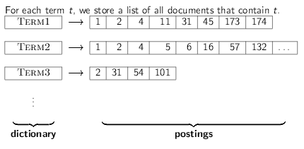

Inverted Index Construction

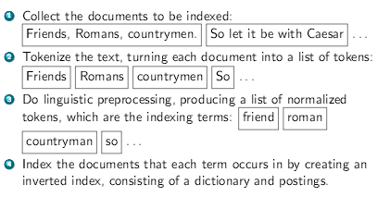

Intersecting Two Posting Lists

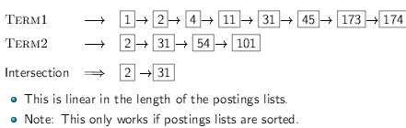

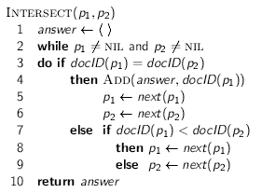

What is a Token?
- A token is a sequence of characters in a document.
- Example Friends / Romans / Countrymen are tokens in an input.

What is a Term?
- A term is a (normalised) word type, which is an entry in our IR system dictionary.
- We need normalise words in indexed text as well as query words into the same form

What is Lemmatization?
- To reduce inflectional / variant forms to base form
- Example : am, are, is -> be
- Example : car, cars, car’s, cars’ -> car

What is Stemming
- Reduce terms to their “roots” before indexing

Bigram (k-gram) Indexes

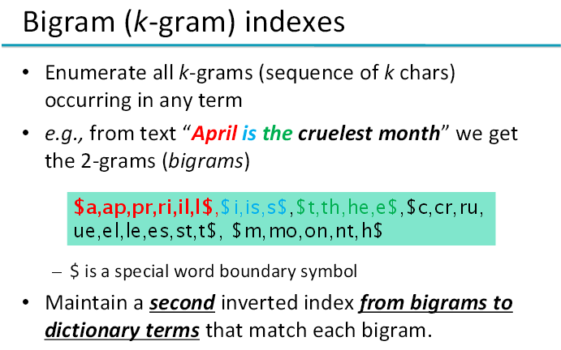

Edit Distance

- Given two strings S₁and S₂, the minimum number of operations to convert one to the other
- Operations : Insert, Delete, Replace (Transposition)
- Example : dof -> dog = 1
- Example : cat -> act = 2 (1 transposition)
- Example : cat -> dog = 3

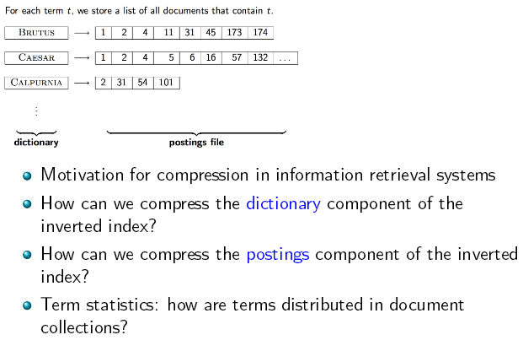

Why Compression?

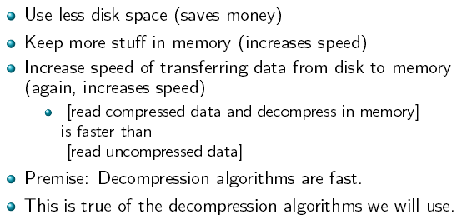

Why compression in IR?

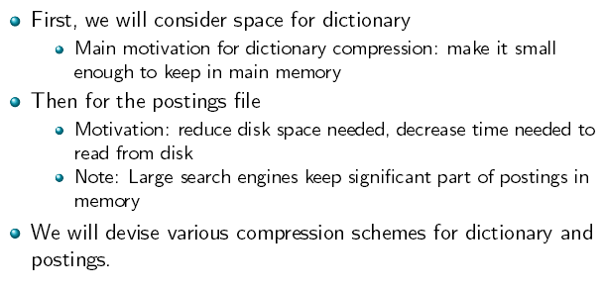

Lossy vs Lossless Compression

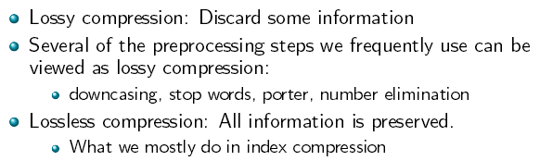

How big is the term vocabulary?

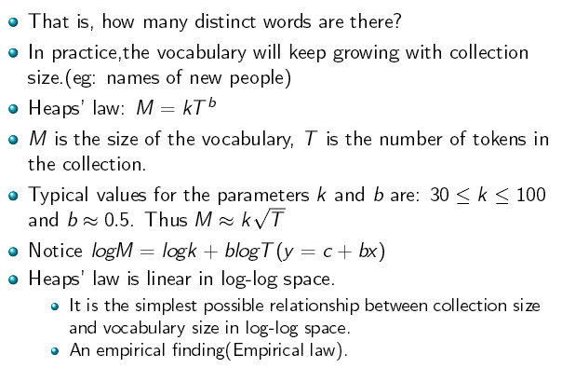

Heaps Law for Reuters
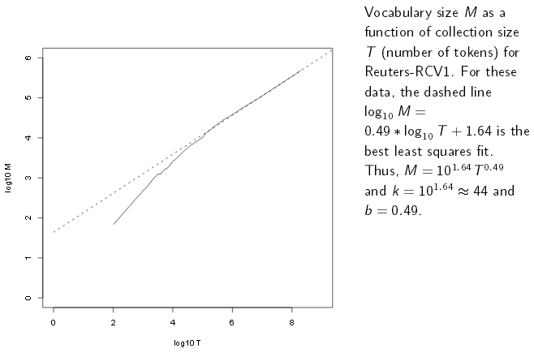

Empirical fit for Reuters

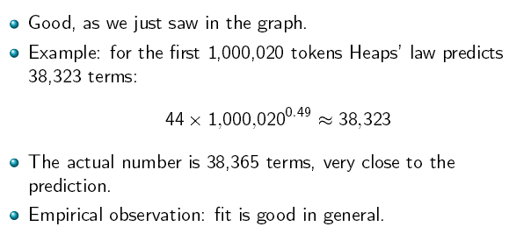

Basic Knowledge to Remember

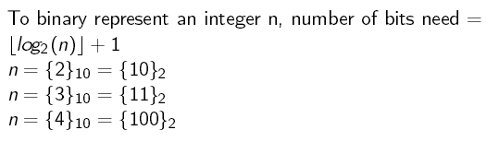

Dictionary Compression

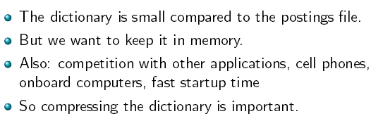
Recall : Dictionary as Array of Fixed-Width Entries

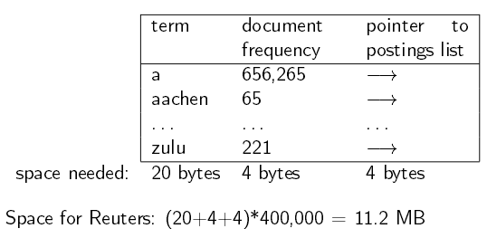

Fixed-Width Entries are Bad !

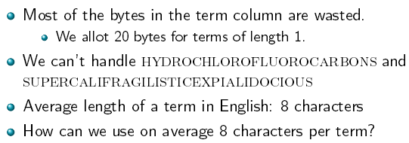

Dictionary as a String

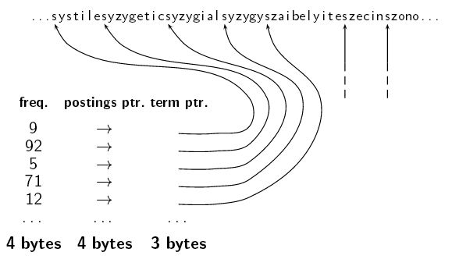

Space for Dictionary as a String

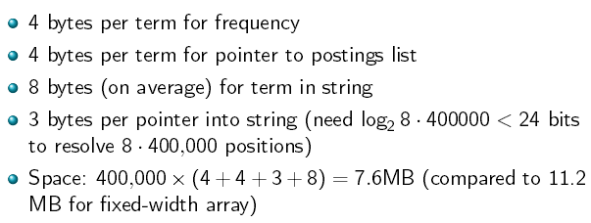

Dictionary as a String with Blocking

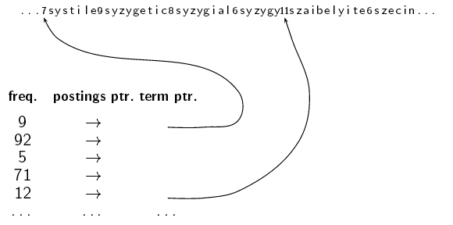

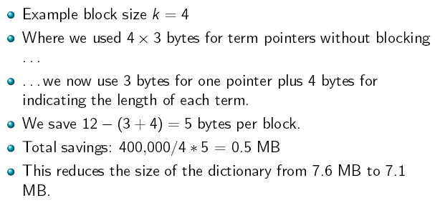

Lookup of a term Without Blocking

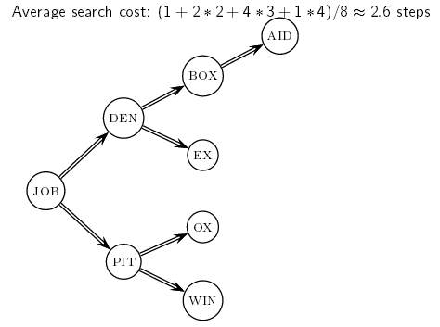

Lookup of a term with Blocking (slightly) slower

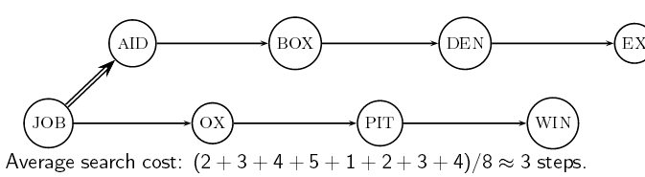

Postings Compression

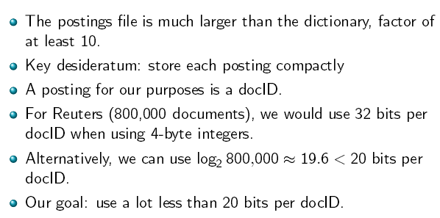

Key Idea : Store Gaps instead of docIDs

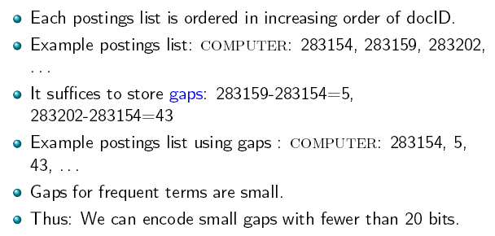

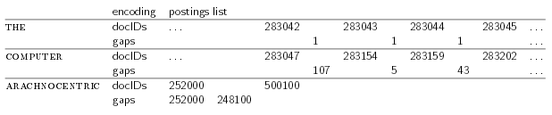

Variable Length Encoding

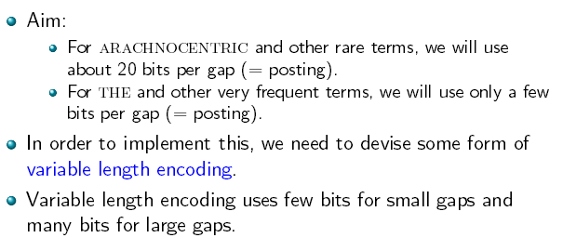

Variable Byte (BV) Code

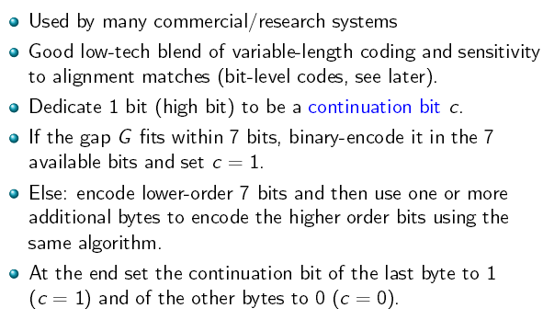

Examples

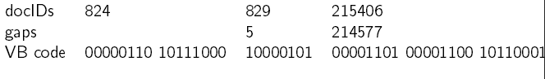

Gamma Codes for Gap Encoding

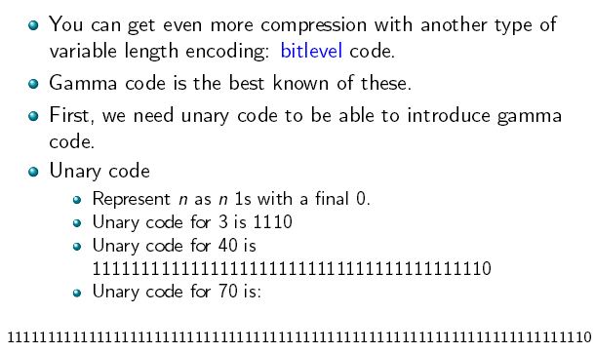

Gamma Code

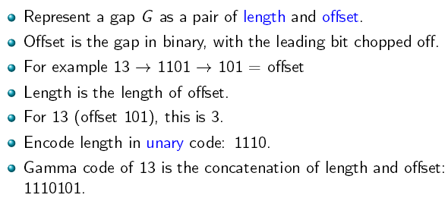

Length of Gamma Code

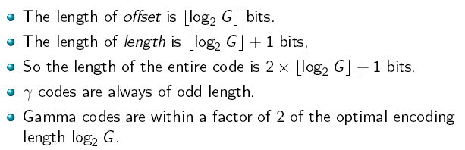

Simple Boolean vs Ranking of Result

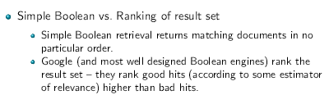

Ranked Retrieval

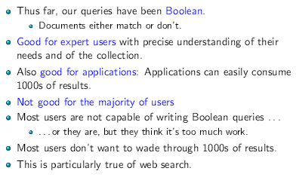

Problem with Boolean Search : Feast or Famine

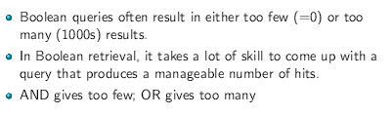

Scoring as a basis of Ranked Retrieval

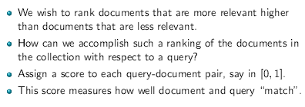

Jaccard Coefficient

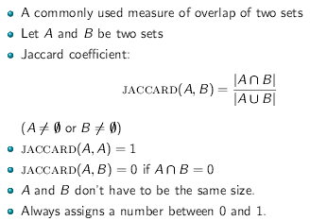

Example

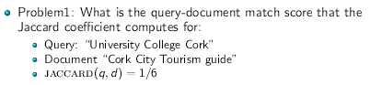

What’s wrong with Jaccard?

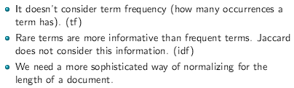
Tf-idf Weighting

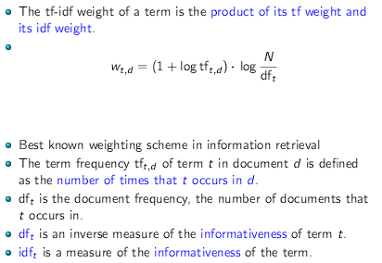

Computing TF-IDF : Example

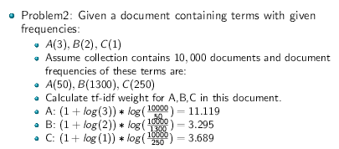

Binary Incidence Matrix

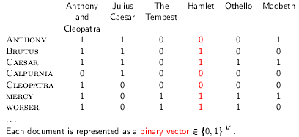

Count Matrix

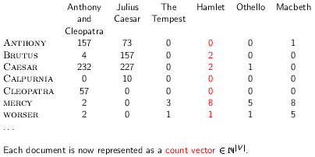

Binary -> Count -> Weight Matrix

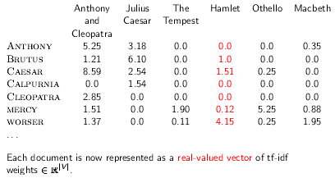

Summary : Ranked Retrieval in the Vector Space Model

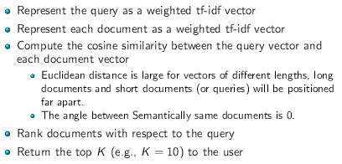

Cosine Similarity between Query and Document

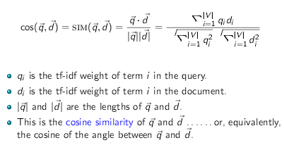

Ranked Retrieval in the Vector Space Model Example

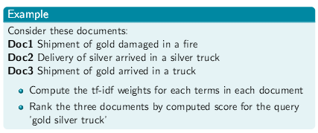

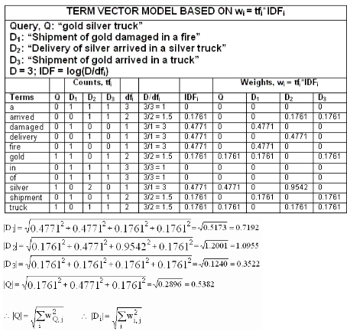
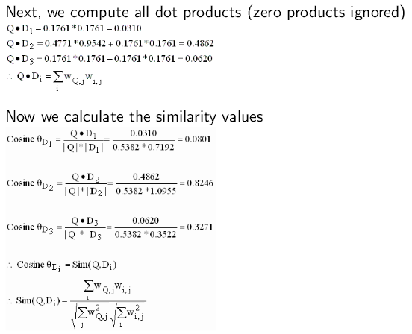

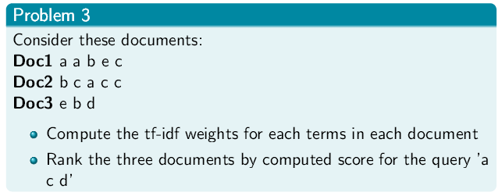

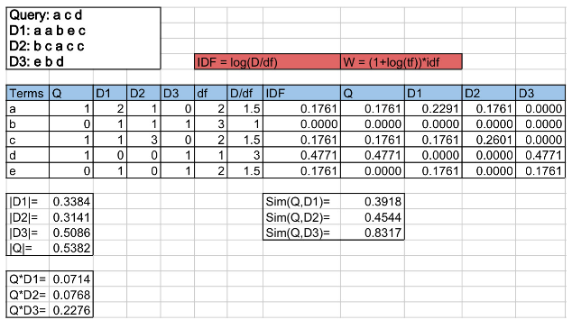

Precision and Recall

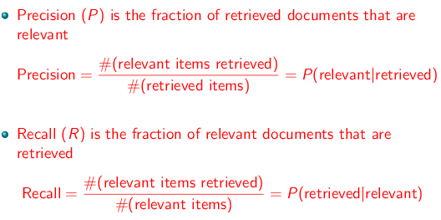

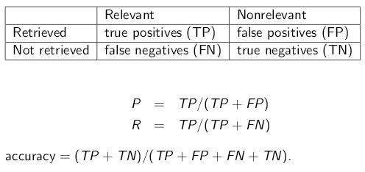

Accuracy

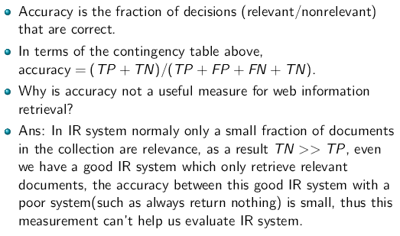

Exercise

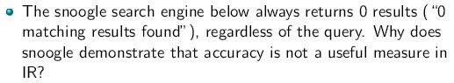

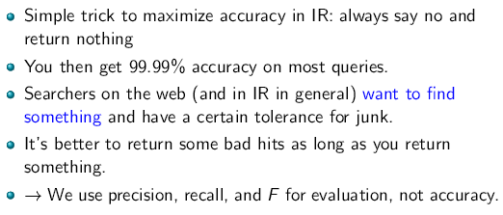

Precision / Recall Tradeoff

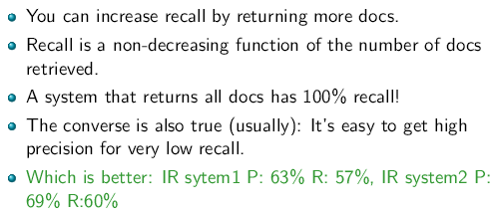

A Combined Measure : F

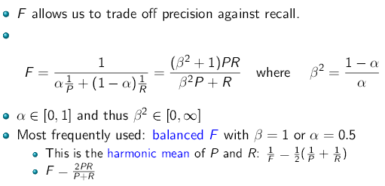

F : Exercise

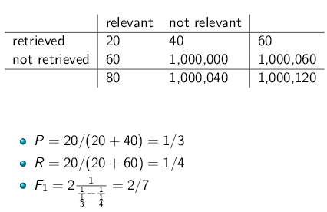

F: Why Harmonic Mean?

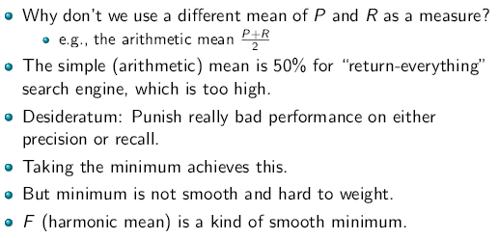

Difficulties in using Precision, Recall and F

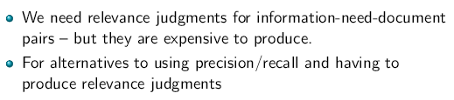

Framework for the Evaluation of an IR System

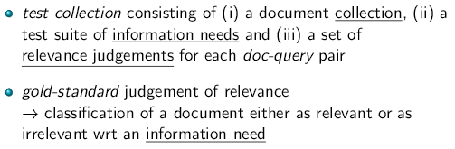

Assessing Relevance

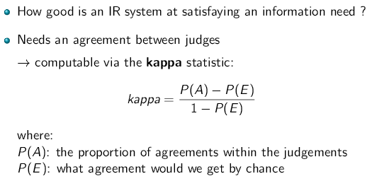

Example:

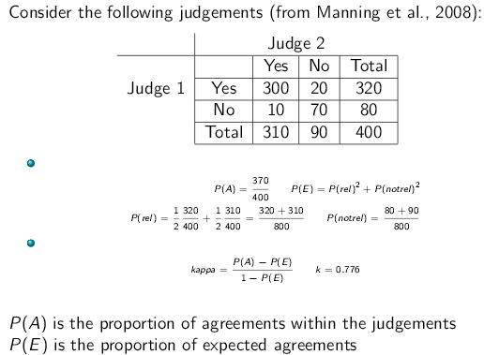

Relevance Continued

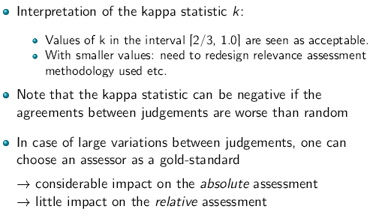

Markov Chains

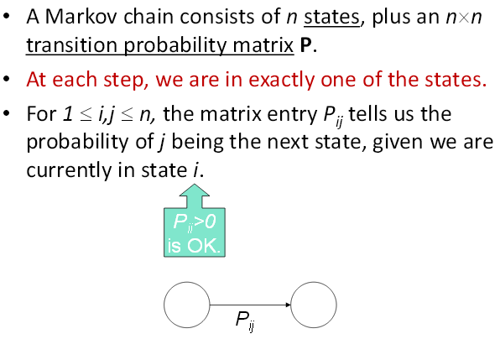

Example

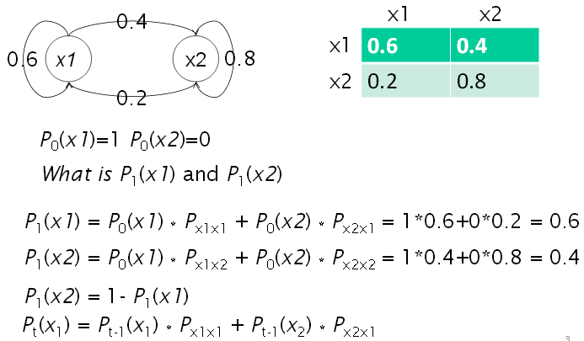

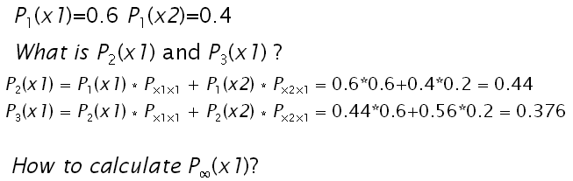

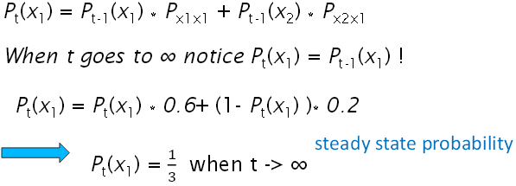

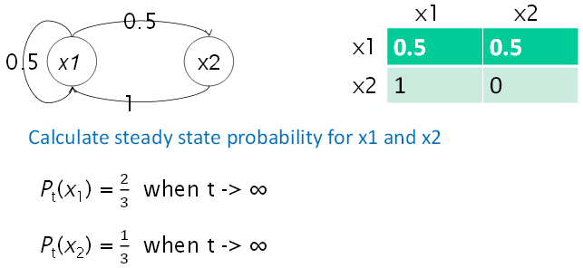

Model Behind PageRank : Random Walk

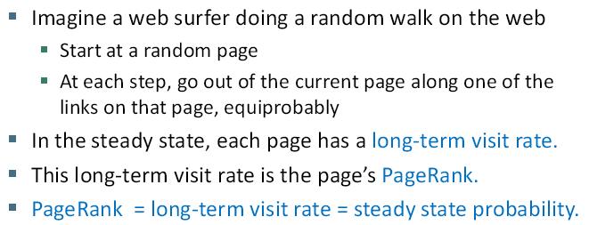

Example Web Graph

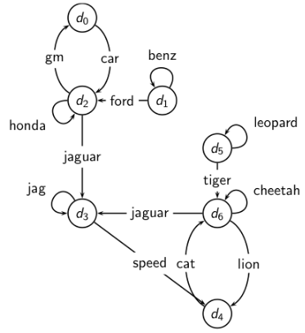

Link Matrix for Web Graph  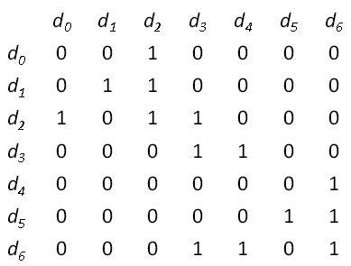 |  | Transistion Probability Matrix P for Web Graph  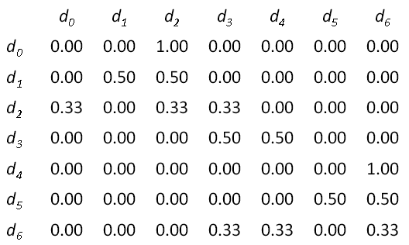
Long Term Visit Rate

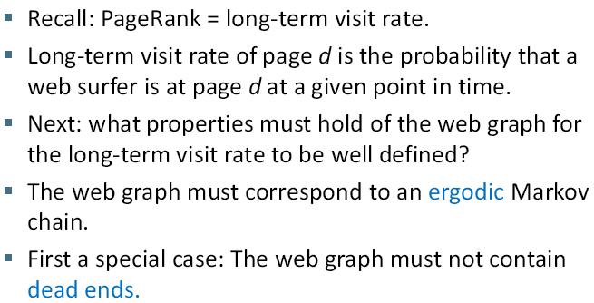
Dead Ends

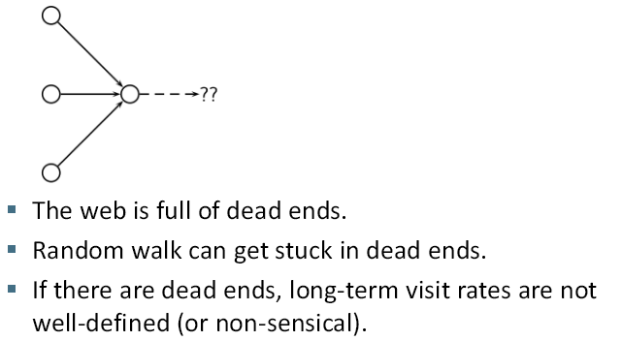
Teleporting – to get us of dead ends  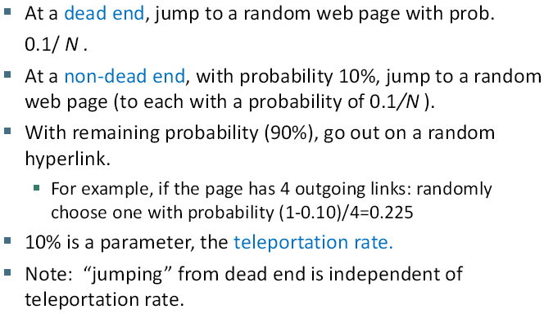 |  | Transition matrix with teleporting  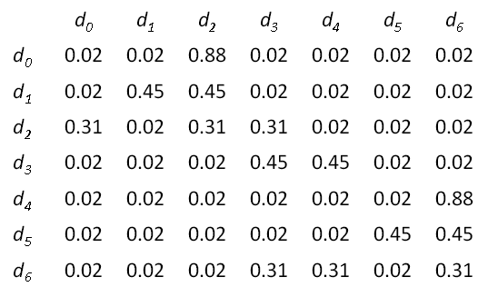
Result of Teleporting

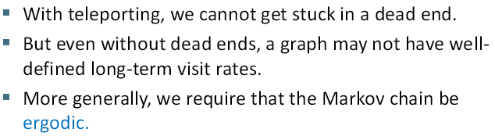
Ergodic Markov Chains

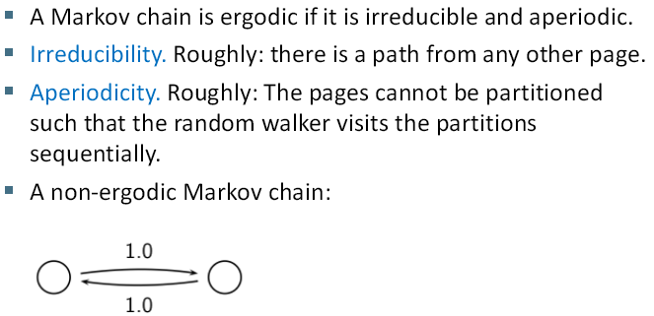

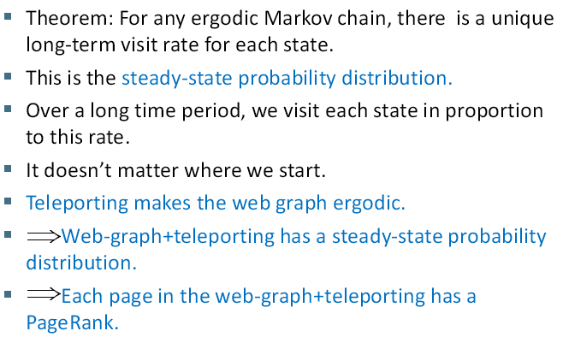

Formalisation of “visit” : Probability Vector

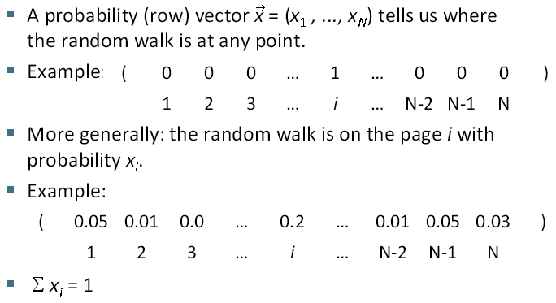

Change in Probability Vector

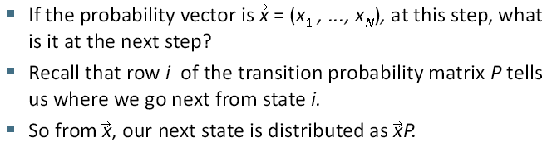

Steady State in Vector Notation

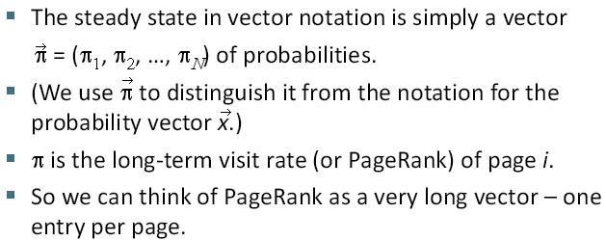

Steady-State Distribution : Example

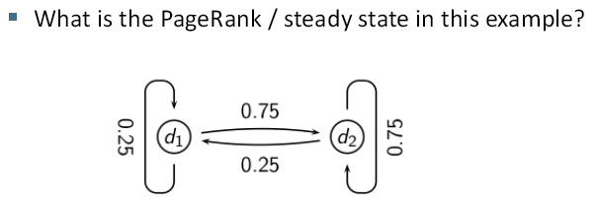

One way of Computing the PageRank

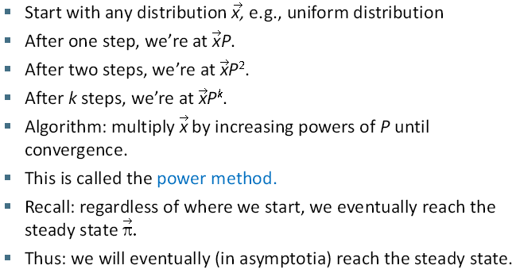
Computing PageRank: Power Example

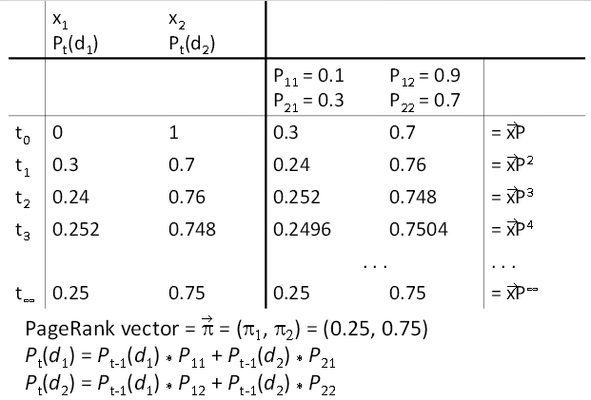

PageRank Summary

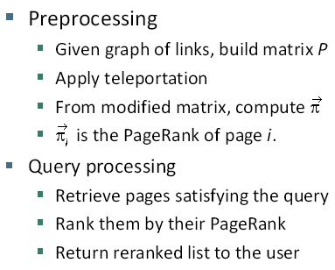

PageRank Issues  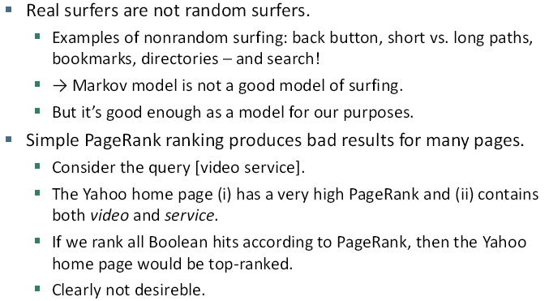 | 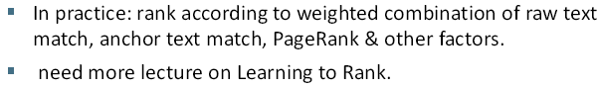
How Important is PageRank?

